GITHUB REPORT

Github account:bbyy: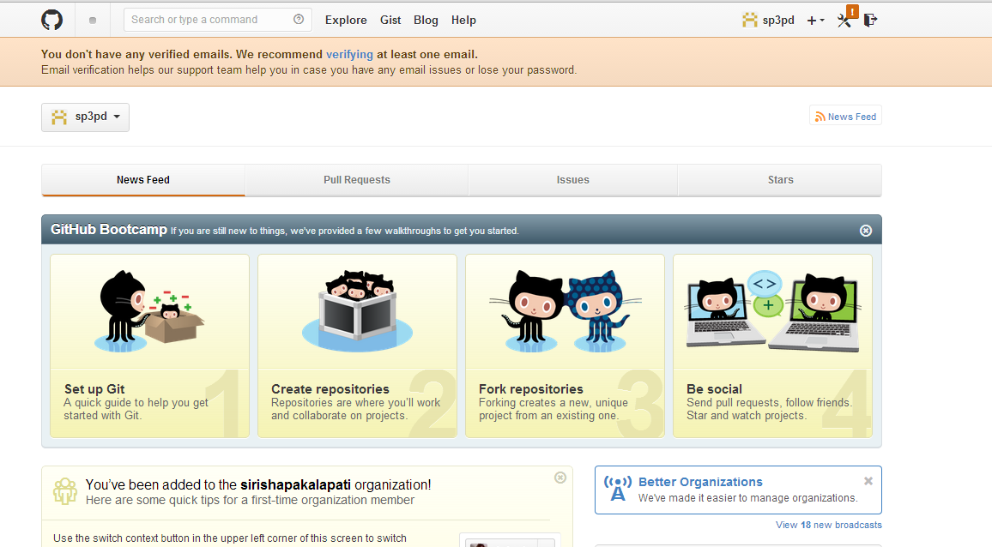

Creating a new repository 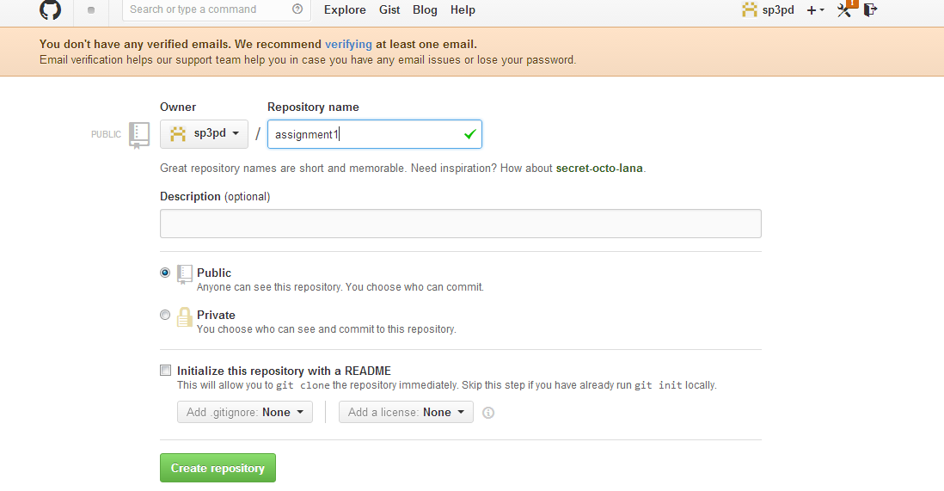 Got the created repository in the local machine 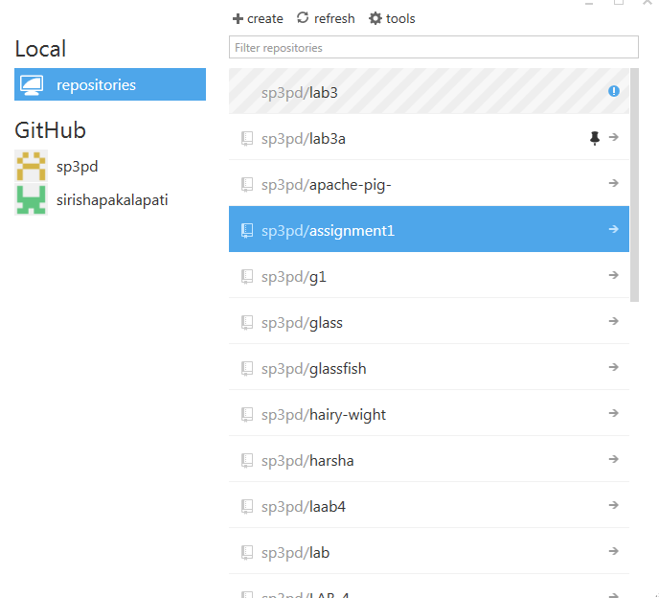 By making the changes to the local repository and publishing it I can post it to the spreadsheet.